Trent Giever

Ch 11 Authentication and Account Management

Project 11-2

7/16/18

Project 11-2 Cracking Passwords using Hackcat GUI

11-2-9

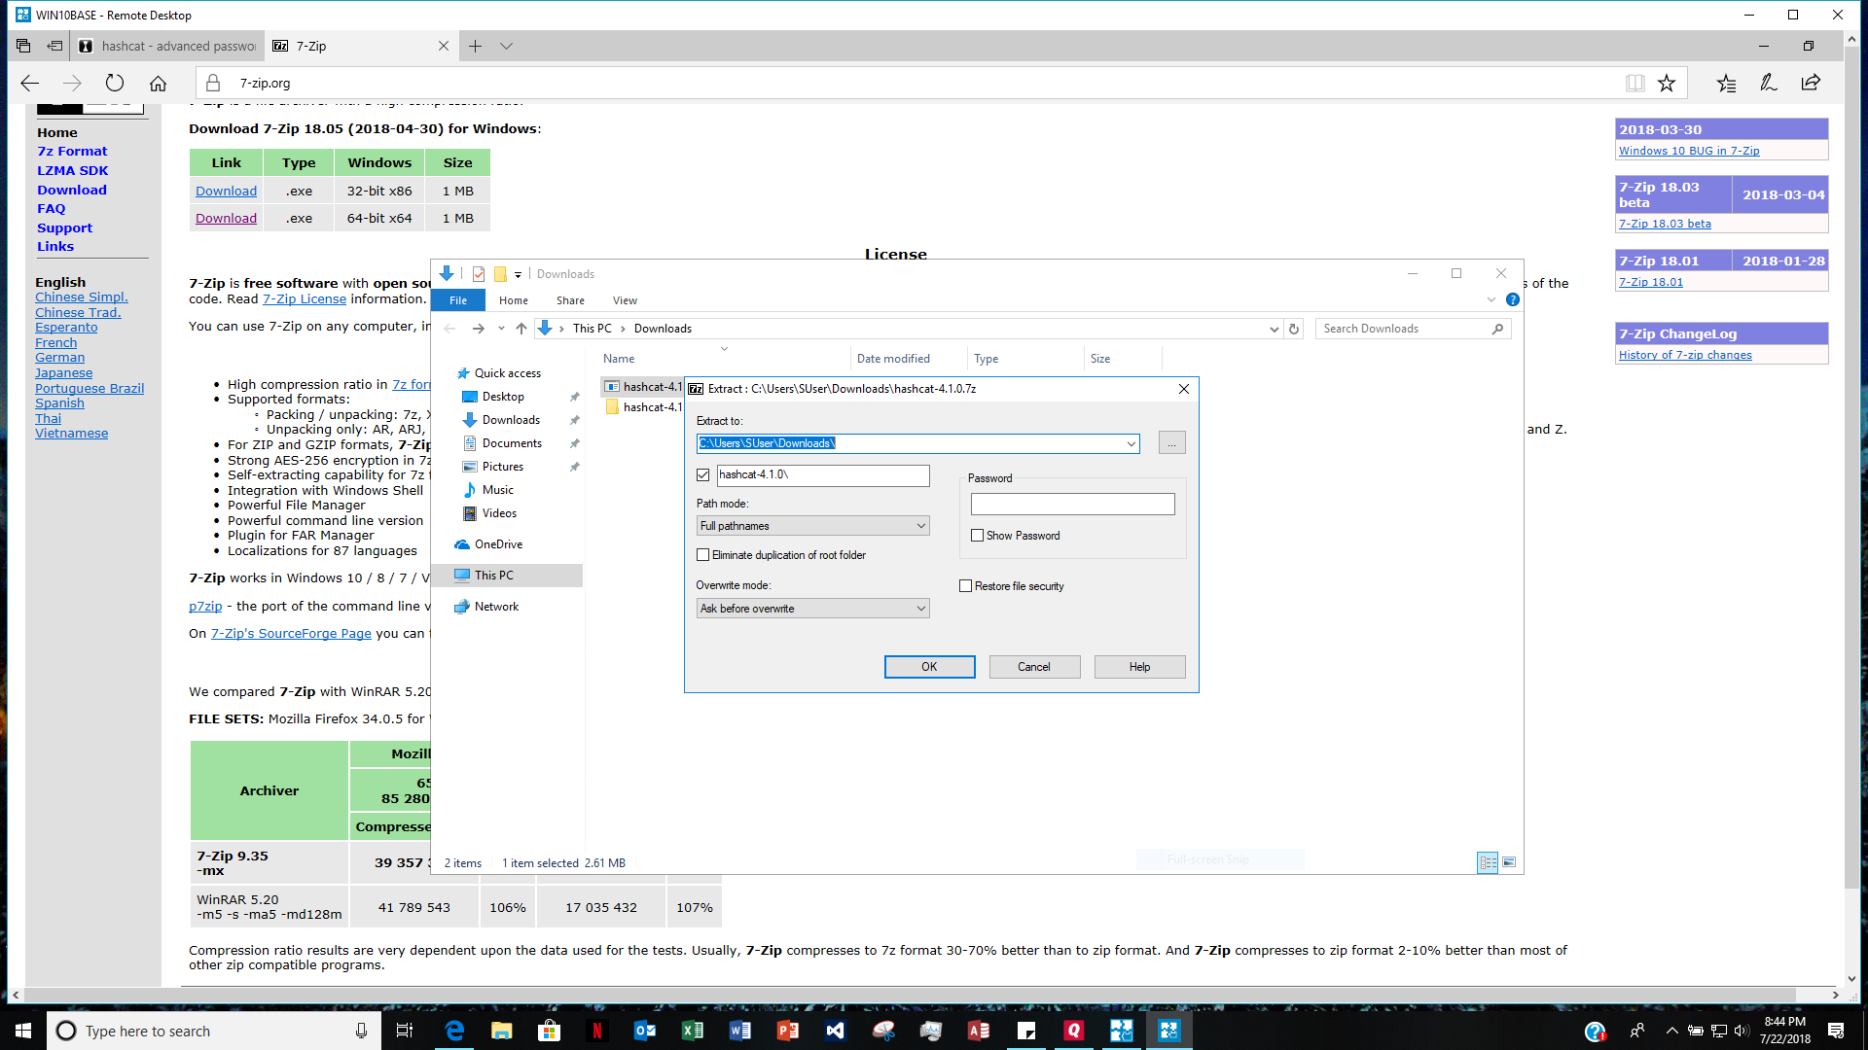

11-2-10

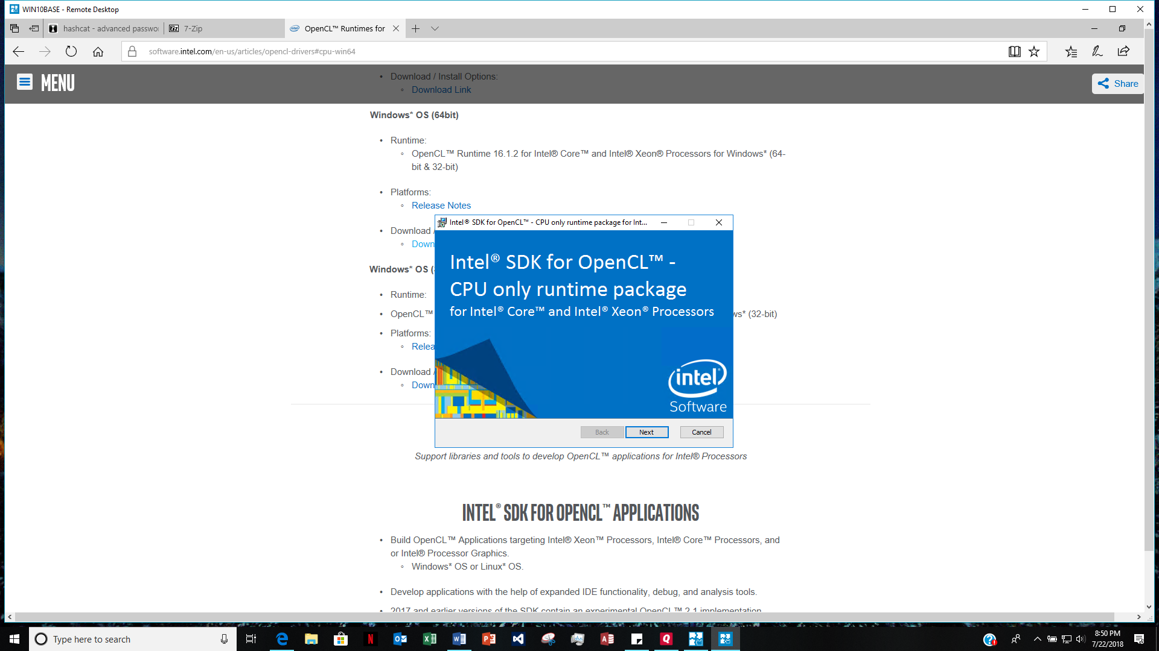

11-2-40

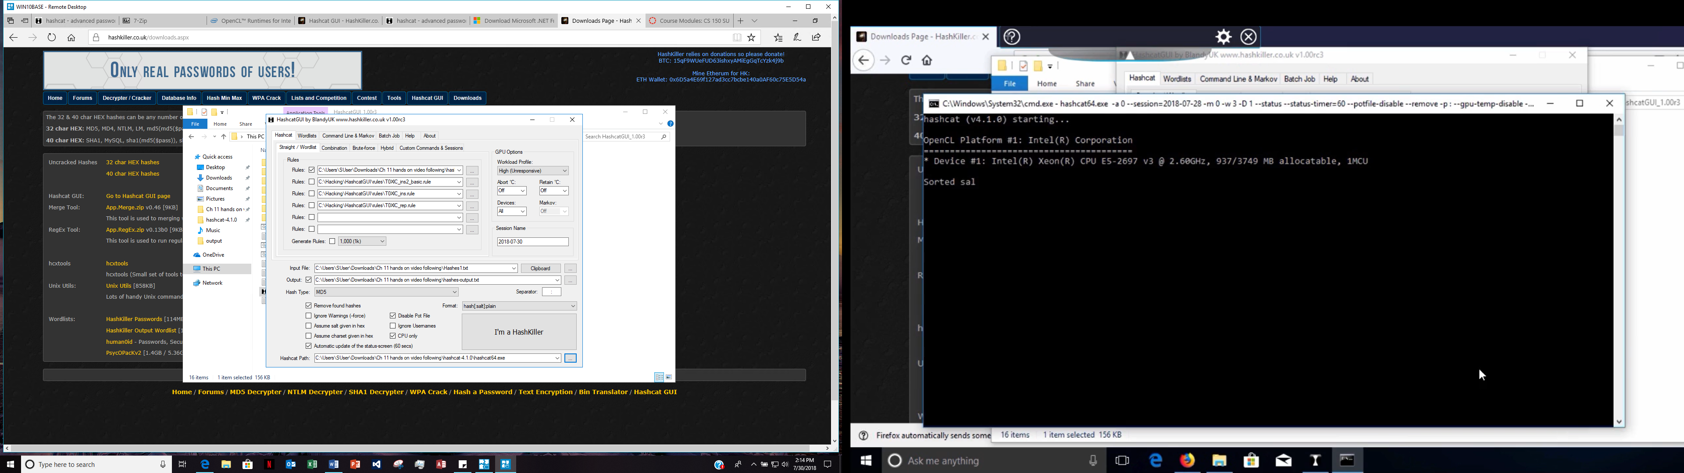

11-2-42

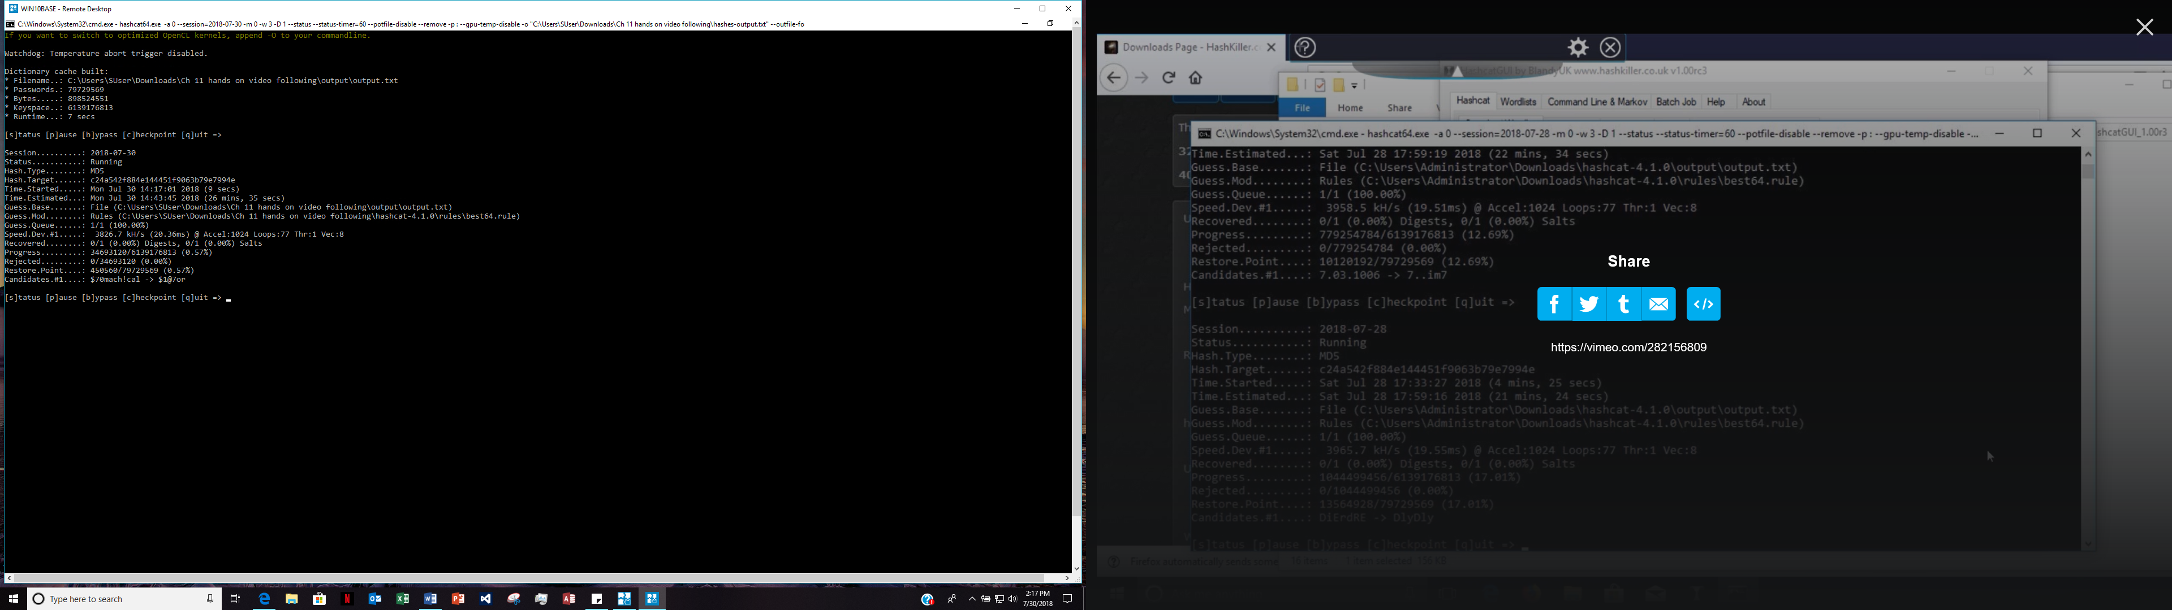

11-2-43

